Paper size A4. Normal font Arial 10pt, line spacing 1.05.
Top, Bottom, Left, Right margins all currently set to 2.1cm, please don’t change.

P008: Title of the paper using Title Style
P008 is an example of the paper number assigned to your paper by the Scientific Committee

A. N. Author, Affiliation an.author@company.com [add email address of corresponding author]
X. Y. Author, Affiliation

Summary (using Heading 1 Style)
Summary text up to 500 words, ideally a single paragraph (using “Summary and keywords” Style)

Key Words (using Heading 1 Style)
Up to eight keywords, separated by commas (using “Summary and keywords” Style).

Introduction (using Heading 1 Style)
Introductory text Introductory text Introductory text Introductory text Introductory text Introductory text Introductory text Introductory text Introductory text Introductory text Introductory text Introductory text Introductory text Introductory text Introductory text Introductory text Introductory text Introductory text (using “Normal” Style).
Citing references can be done manually or using any bibliography software (Zotero, EndNote, …).
[Optional] Alternatively, automatic links can be used in MS Word: go to menu References/Cross-reference. Choose Numbered item in the “reference type” menu and “Paragraph number” in the “insert reference to” menu”. For example: “according to [1], viscoplastic strain, …”. In case of multiple references, use rather manual citing instead of automatic one. separate the first and last numbers of a list of a consecutive references with a “-“, separate non-consecutive references by a “;”.

Headings (using Heading 1 Style, do not number headings)
More text More text.

Subheading (using Heading 2 Style. Do not number subheadings)
Even more text.

Subsubheading (using Heading 3 Style. Do not number subsubheadings)
Example bulleted list (using list paragraph style)
- Bullet
- Bullet
- Bullet

Text Elements
The following gives advice on style for figures, tables, and equations, with some Optional advice on how to achieve such styles in MS Word.

Figures and Tables
An example figure and table are given below. Preferably they should be within the text and centred, but they may also be entered at the end of the paper if necessary.
[Optional] Automatic numbering of figures and tables can be performed in MS Word using References/Insert Caption and choose the appropriate label (Figure or Table).
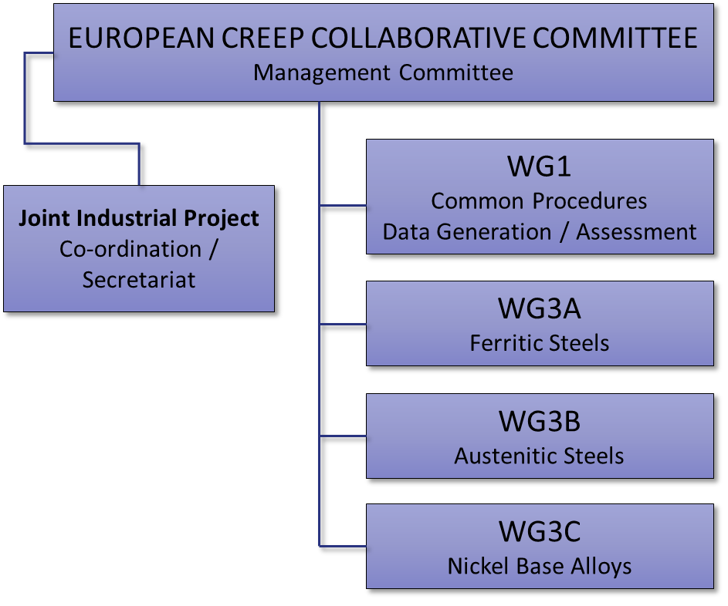
Figure 1: Figure Title, use Figure & Table Style below the figure
[Optional] Automatic referring to figures and tables in MS Word can be performed using References/Cross-reference and chose the appropriate type in the reference type menu and “Only label and number” in the “insert reference to” menu. For example: “The ECCC organization chart is plotted in Figure 1 and the names of people responsible for each area are listed in Table 1”.
Eventually, once the paper is finished, if necessary, the author can select in MS Word all the content of the file (Ctrl + A on windows systems) and then press “F9” on the keyboard to update all caption and cross references numbers.

Table 1: Table Title, use Figure & Table Style above the table
MC / EXEC | A. Di Gianfrancesco | Italy
WG1: Data Generation & Assessment Procedures | M. Schwienheer | TU Darmstadt, Germany
WG3A: Ferritic/ Martensitic | J. Hald | Technical University Denmark
WG3B: Austenitic | L. Vincent | CEA, France
WG3C: Superalloys | E. Poggio | Ansaldo Energia, Italy
Secretariat | I. Salvatori | RINA-CSM, Italy

Equations
Equations should be centred and labelled with a number between parenthesis on the right hand side of the line. Using MS Word, the font size may need to be increased slightly to show sub- and superscripts. The example below uses Cambria Math font, 12pt (so that super and sub-scripts etc are more easily read).
[Optional] Within MS Word a two-column table may be used as follows. First, introduce a one line and two columns table with the width of the right column reduced to the minimum size necessary to insert the label number. Choose “no border” to make them disappear. Second write the equation inside the left column using the word equation editor. Third, insert an automatic label number on the right column using References/Insert Caption. In the Label menu, choose “ ( “ (if not already existing, create it with “new label”) and click ok. Complete the end of the label on the table by closing the parenthesis. For subsequent equations, simply copy and paste one such table containing an equation and a label number to where you want to add a new one in your text, replace the former equation by the new one and then right click on the label number and chose “update field”.
Below is an example already prepared that can be copied and pasted, then modified for this purpose
$$\frac{σ}{σ_{TS}}=exp\left\{-k_{1}{\left[t_{f}exp\left(\frac{-Q_{c}^{*}}{RT}\right)\right]}^{u}\right\}$$ | (1)

Referring to equations within the text should be of the form, “from Eq.(1), …”.
[Optional] An automatic way to do it in MS Word is to use References/Cross-references, then select “ ( “ in the reference type and chose the appropriate number you want to refer to.

Acknowledgements
Example - we wish to acknowledge **** and thank ****.

References
- Reference 1 using References style.
- Reference 2 using References style.

Please use the following “APA” type layout.

- Holdsworth, S.R. and Davies, R.B., (1999). A recent advance in the assessment of creep rupture data. Nuclear Engineering and Design, 190(3), pp.287-296.

[Optional] If available please include the DOI, such as below.

- Holmström, S., (2016). Defining a negligible creep temperature curve for Gr. 91 steel, International Journal of Pressure Vessels and Piping, 146, pp198-202. https://doi.org/10.1016/j.ijpvp.2016.07.004.

